File: Edgar Lavington history for Pamphonic.doc

Biography written by SHL for the website http://www.pamphonic.co.uk/ 22/5/2012.

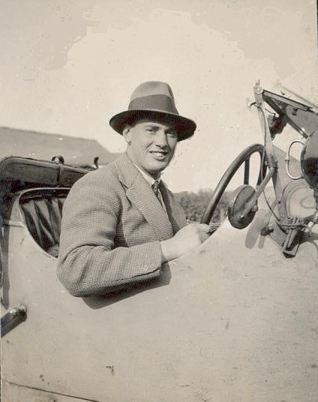
Edgar Lavington in about 1935.

Edgar Lavington was born on 14th November 1908 to Edward and Kate (neé Ancell) Lavington of 26 Holmewood Gardens, Streatham Hill, south London. Edgar’s father was an accountant, working for the Capital & Counties Bank Ltd., Threadneedle Street. Edward died of influenza in 1917 and Edgar’s mother could not afford to send her son to Dulwich College as planned. Edgar was, by his own account, an adventurous boy who enjoyed sports and nearly got expelled from school after causing an explosion in the Chemistry Lab. As a young man, he delighted in sports cars – in the 1930s he owned an Aston Martin. In 1937, he took up gliding and later gained his Pilot’s Licence in June 1939, flying a Tiger Moth from Redhill in Surrey.

Returning to his early days, after attending Dulwich Preparatory School until 1921, Edgar went to Belmont College, south London, from 1922 – 26. He then ‘crammed’ for a few months at University Tutorial College before going to Faraday House Electrical Engineering College, Southampton Row, London, in April 1927. He received his Diploma in June 1931. The four-year course at Faraday House involved periods of study interleaved with two extended secondments to industry. Edgar spent the period April 1928 to April 1929 at the East Ferry Road Engineering Works Co. Ltd., London, and June 1930 to June 1931 at Standard Telephones & Cables Ltd., working principally in Newcastle on the installation of a Telephone Exchange.

It was at Faraday House that Edgar met Paul Taylor, his future business partner and lifelong friend. In 1931 both men got their first full-time employment at Standard Telephones & Cables Ltd. but were made redundant only a few weeks later when the company experienced financial difficulties. Like many others in the years of the depression, Edgar and Paul started up in business on their own towards the end of 1931. This was the Zenith Sound Reproduction Co., registered at 56 Albert Road, Regents Park, London NW – (Paul Taylor’s mother’s house). The company name was later changed to Pamphonic Reproducers Ltd., and the name of the road became Prince Albert Road.

Not long after starting the business, Edgar broke his nose playing rugby and, from 17th May to 24th June 1932, he became seriously ill with general septicaemia. He lost most of his hair, taking several weeks to recover and unable to return to work until 3rd August. His mother died on 5th June but Edgar was so ill that he was not informed until several days later. In 1934 Edgar moved from the family home in Streatham to Cumberland Mews, Regents Park, and then in 1936 to a nearby smart block of flats called The White House. By now Pamphonic Reproducers Ltd. had moved to 45 St Pancras Way. By 1939 the company’s address was given as 45 Kings Road, London NW1. In November 1937 Edgar was elected an Associate Member of the Institute of Wireless Telegraphy and of the British Institute of Radio Engineers, and then in April 1938 he was elected an Associate Member of the Institution of Electrical Engineers. In June 1939 he married Jane Nicklen.

With the onset of war, Pamphonic was put into cold storage and Edgar Lavington and Paul Taylor volunteered for the RAF. After basic training in Wiltshire, Edgar was formally commissioned as a Pilot Officer in July 1940. Following a time at 60 Group Bawdsey Manor, Edgar was posted to Northern Ireland in November 1940 to set up the first CH radar station there, at RAF Glenarm. He returned in September 1942 to work on radar station maintenance in Kent and southern England. In March 1943 he moved to RAF 60 Group Headquarters at Leighton Buzzard. In March 1944 he was seconded to the Admiralty Signals Establishment, Lythe Hill House, Haslemere, to work on fighter direction centralised control systems. He was demobilised in November 1945, with the rank of Squadron Leader. He retained his commission in the RAFVR until February 1954.

On 1st December 1945 Edgar re-joined Pamphonic at its ‘cold storage’ location at Cambridge and by January 1946 had found suitable new premises for the company at a factory at Westmoreland Road, London NW9 (on the borders of Stanmore). By April 1946 Edgar’s wife Jane and their three children (Simon, Sarah Jane and Diana) had moved to a house two miles from the factory, at Wembley Park.

Edgar continued to work as Managing Director of Pamphonic, with Paul Taylor as the Technical Director. By the late 1950s, Edgar had become unhappy at the way in which Pye was taking increasing control of the direction of Pamphonic and, after some stormy Directors’ meetings, Edgar resigned with a ‘golden handshake’ on 30th November 1959. Severing connection with the company that he’d helped to found must have been doubly painful since, in October 1959, Edgar’s son Simon had just begun a degree course in Electrical Engineering with the unwritten expectation that he would some day join the ‘family firm’.

From 1960 until his death, Edgar worked as a Management Consultant – at first collaborating with a city firm of receivers helping ailing companies to re-trench. Then in 1963 Edgar took a managerial interest in the electrical component company Repanco Ltd. of Coventry. By September 1964 he had put some of his own money into Repanco and had become joint Managing Director. In the end this proved to be a difficult assignment: his co-Director died in 1971 and the successor had a nervous breakdown.

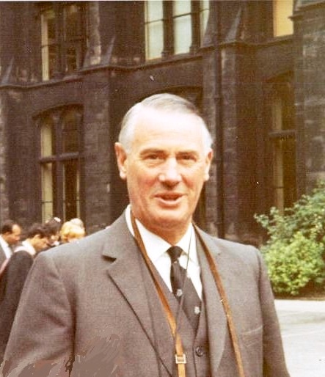
Edgar Lavington in 1967.

From 1960 Edgar started to sail racing dinghies, eventually owning a Merlin Rocket and taking a part in organising class events. Meanwhile Edgar continued as a Director of Repanco, spending at least four days a week in Coventry. In January 1981 Edgar was diagnosed with cancer. He died on 14th May 1982.

Simon Lavington.
lavis@essex.ac.uk

